14 July 2015
Ambassador meets students of The Hague Academy of International Law

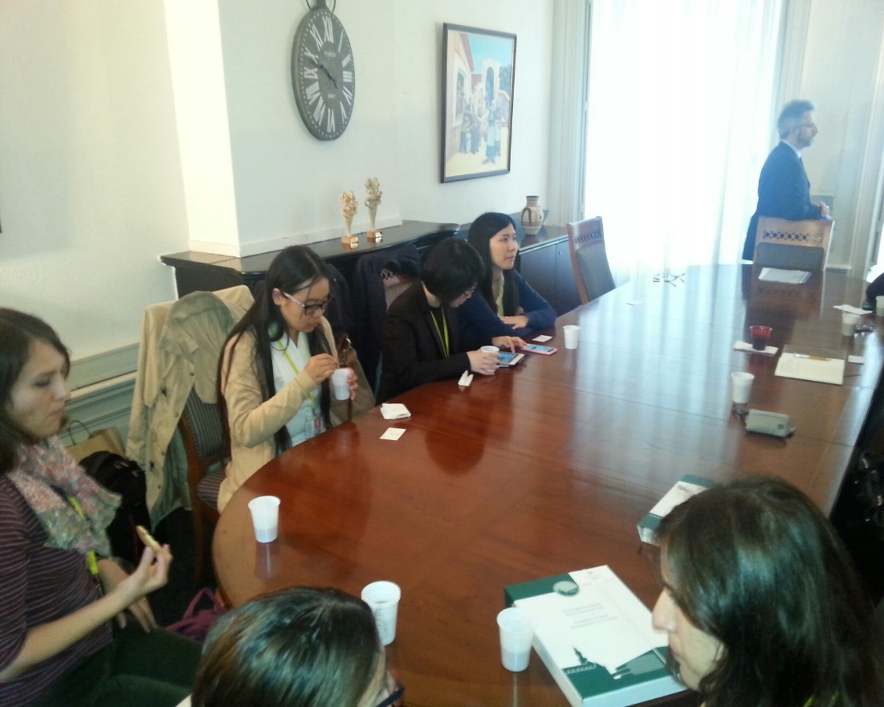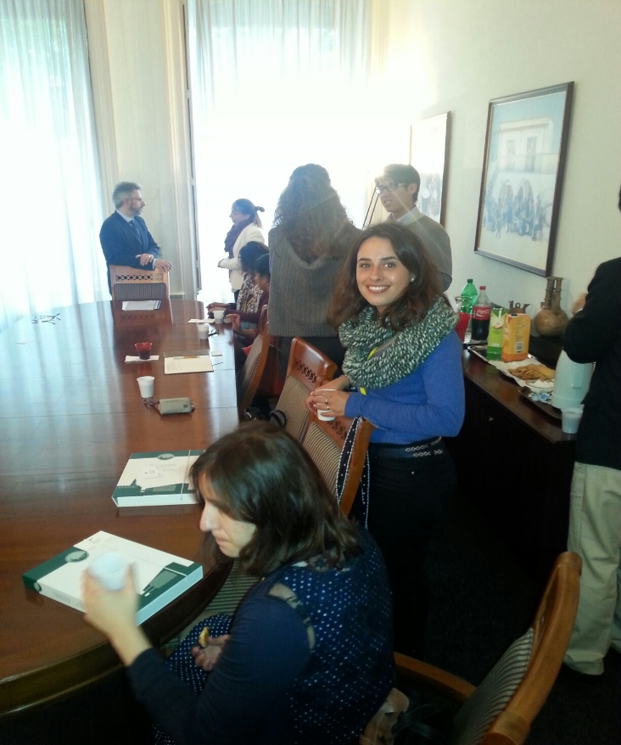

On 14 July 2015 Ambassador Kyriacós P. Kouros hosted at the Embassy of Cyprus a group of students of The Hague Academy of International Law. Ambassador Kouros presented a general overview of diplomacy from the perspective of Cyprus, the history and latest developments on the Cyprus Question and on Cyprus economy. The Ambassador described the work and the priorities of the Embassy of Cyprus in The Hague both on the bilateral and multilateral level. In respect to the latter, he explained the Embassy’s work representing Cyprus in the Organisation for the Prohibition of Chemical Weapons and the International Courts and Legal Organizations and Institutions based in The Hague.

